Software Design Description

for

“Autonomous Portable Dual-Axis Solar Charging Station with Shadow- Avoidance Mobility”

List of Figures
List of Tables
Figure No. | Description | Page
Figure 1.0 | System Architecture | 47
Figure 2.0 | Entity-Relationship Diagram | 53
Figure 3.0 | Telemetry Polling Sequence Diagram | 54
Figure 4.0 | Manual Command Sequence Diagram | 54
Figure 5.0 | Solar Station Dashboard | 55
Figure 6.0 | Analytical Charts & Trends | 55
Figure 7.0 | System Status & Event Monitoring | 56
Figure 8.0 | Sensor Log Interface | 56
Figure 9.0 | Live Dashboard Interface | 57
Figure 10.0 | Control Interface | 58
Figure 11.0 | Event & Logs Interface | 59
Figure 12.0 | Settings Interface | 60

Figure No. |  | Description | Page
Table 1.0 |  | Definition, Acronyms, and Abbreviations | 45
Table 2.0 |  | Sensor Log | 48
Table 3.0 |  | Manual Command | 49
Table 4.0 |  | System Event | 50
Table 5.0 |  | Upload Status | 51
Table 6.0 |  | System Configuration | 51

1. Introduction

1.1. Purpose

This document aims to present the design and development of the Autonomous Portable Dual-Axis Solar Charging Station with Shadow Avoidance Mobility. It explains the overall system design, including both hardware and software components. The general structure, functionalities, and current status of the system are highlighted in this report.

1.2. Scope

This document describes the system design of the Autonomous Portable Dual-Axis Solar Charging Station with Shadow Avoidance Mobility. It explains how the system is constructed by identifying the components used, how they interact with each other, and the overall design principles of the system.
The following are functionalities covered by the system:
- Solar Tracking & Energy Harvesting
  - Dual-Axis Panel Control: Functionality that automatically orients the solar panel along horizontal and vertical axes to track the sun’s movement and maximize energy absorption.
  - Light Intensity Sensing: Functionality that uses LDR sensors to measure sunlight intensity and determine the optimal position of the solar panel.
- Shadow Detection and Mobility
  - Shadow Sensing: Functionality that detects reduced light intensity caused by shading.
  - Shading Decision Logic: Functionality that evaluates real-time light conditions and determines when relocation is necessary.
  - Autonomous Relocation: Functionality that allows the system to move toward areas with better sunlight exposure.
  - Obstacle Detection and Avoidance: Functionality that ensures safe movement by detecting and avoiding obstacles.
- Monitoring and Communication
  - Data Acquisition: Functionality that collects real-time system data such as light intensity and movement status.
  - Wireless Data Transmission: Functionality that uses ESP32 to send collected data to a web-based platform via WiFi.
  - Real-Time Monitoring: Functionality that displays live system performance and historical data through an online interface.

1.3. Definition, Acronyms, and Abbreviations

Terms | Definition
Arduino | Arduino. A microcontroller-based platform used for controlling electronic components and processing input from sensors such as LDR and ultrasonic sensors in the system.
ESP32 | ESP32. A low-cost, low-power microcontroller with built-in WiFi and Bluetooth capabilities used for wireless communication and real-time data transmission to the web-based monitoring system.
LDR (Light Dependent Resistor) | Light Dependent Resistor. A sensor used to detect light intensity. It is used in the system to determine sunlight direction and detect shadow conditions.
Servo Motor | Servo Motor. An actuator used for precise angular movement, responsible for adjusting the solar panel’s position in dual-axis solar tracking.
Dual-Axis Solar Tracking | Dual-Axis Solar Tracking. A system that allows the solar panel to move along both horizontal and vertical axes to continuously align with the sun for maximum energy absorption.
Shadow Detection | Shadow Detection. A functionality that identifies reduced light intensity using LDR sensors and determines when the system needs to relocate for better sunlight exposure.
Obstacle Detection | Obstacle Detection. A system feature that uses sensors (e.g., ultrasonic sensor) to detect physical obstacles and prevent collisions during movement.
IoT (Internet of Things) | Internet of Things. A network of interconnected devices that communicate and exchange data over the internet, used in the system for real-time monitoring.
Web-Based Monitoring System | Web-Based Monitoring System. An online interface that displays real-time system data such as solar output, movement status, and sensor readings.
Solar Panel | Solar Panel. A device that converts sunlight into electrical energy to power the system and charge the battery.
Battery (12V) | Battery. A rechargeable energy storage unit used to supply power to the system when sunlight is not available.
Charge Controller | Charge Controller. An electronic device that regulates voltage and current from the solar panel to safely charge the battery and protect it from overcharging.

Table 1.0 Definition, Acronyms, and Abbreviations

1.4. References

[1] Arduino Documentation, “Arduino Official Website,” Available: https://www.arduino.cc/. Accessed: April 2026.
[2] Espressif Systems, “ESP32 Technical Reference Manual,” Available: https://www.espressif.com/. Accessed: April 2026.
[3] Adafruit Learning System, “Light Dependent Resistor (LDR) Basics,” Available: https://learn.adafruit.com/. Accessed: April 2026.
[4] J. Fraden, Handbook of Modern Sensors: Physics, Designs, and Applications, Springer, 2016.
[5] S. Monk, Programming Arduino: Getting Started with Sketches, McGraw-Hill Education, 2016.
[6] IEEE Std 830-1998, “IEEE Recommended Practice for Software Requirements Specifications.”
[7] IEEE Std 1058-1998, “IEEE Standard for Software Project Management Plans.”

2. System Architecture

2.1 Class Diagram

2.1.1 A diagram that depicts the overall structure of the Solar Tracker system, illustrating how the user interfaces, backend server, database, and hardware components are interconnected and communicate with each other.

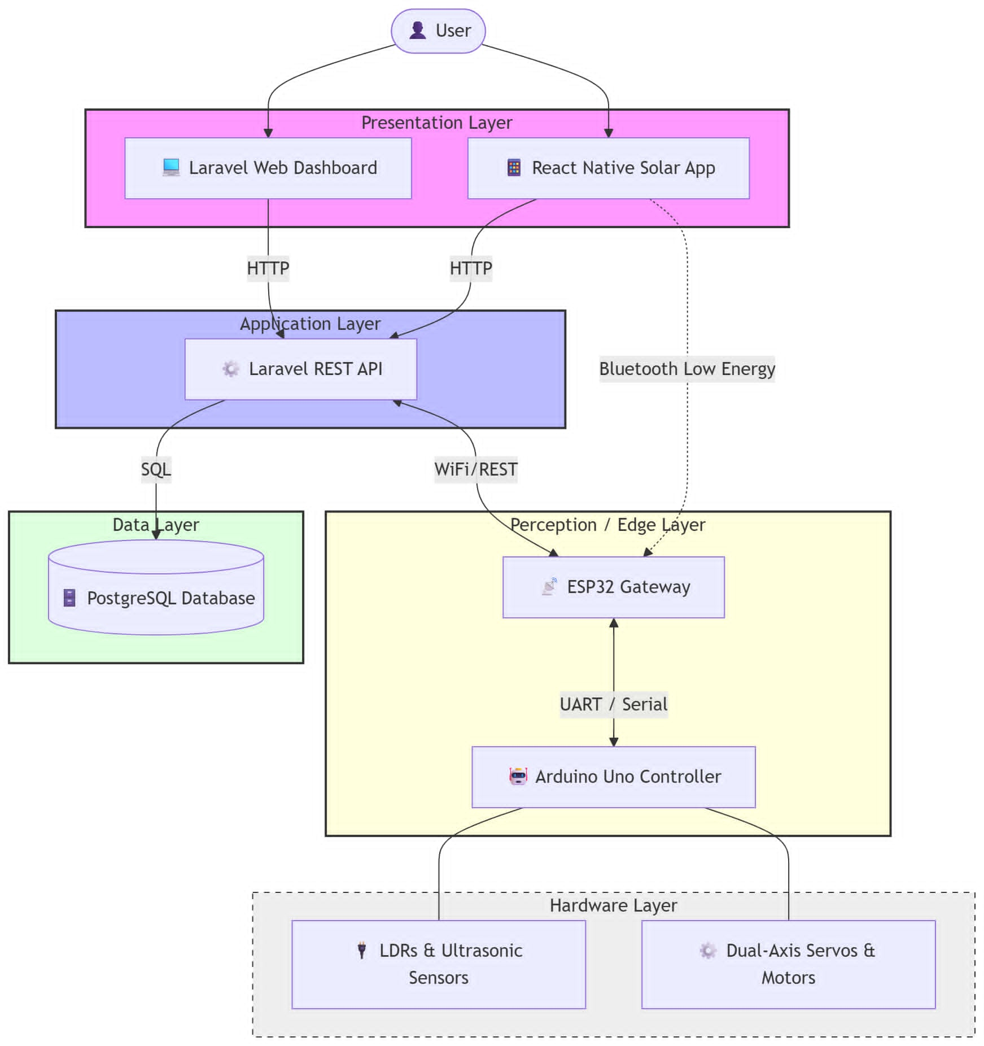

Figure 1.0 System Architecture

3. Data Design

3.1. Data Description

3.1.1 Sensor Log
Table Name: tbl_sensor_log
Table Description: Table where the list of sensor readings and system states from the solar charging station.
Primary Key: log_id
Foreign Key: config_id
Fieldname | Data Type | Length | Description
Log_id | int | 11 | Auto-increment primary key, unique log entry identifier
timestamp | datetime |  | UTC timestamp of the reading
config_id | int | 11 | Foreign key to  tbl_system_config,indicates which calibration settings were active
ldr1 | int | 4 | Light intensity from LDR 1 (top-left), range 0-1023
ldr2 | int | 4 | Light intensity from LDR 2 (top-right), range 0-1023
ldr3 | int | 4 | Light intensity from LDR 3 (bottom-left), range 0-1023
ldr4 | int | 4 | Light intensity from LDR 4 (bottom-right), range 0-1023
ldr5 | int | 4 | Light intensity from LDR 5 (shadow detection -left), range 0-1023
ldr6 | int | 4 | Light intensity from LDR 6 (shadow detection-right), range 0-1023
shadow_detected | unsignedtinyint | 1 | 1 = shadow condition met, 0 = no shadow
is_moving | unsignedtinyint | 1 | 1 = mobility DC motors active, 0 = idle
servo_horizontal_angle | int | 3 | Current angle (0-180) of the panel horizontal servo
servo_vertical_angle | int | 3 | Current angle (0-180) of the panel vertical servo
ultrasonic_distance | float | (5,1) | Distance to nearest obstacle in cm (nullable if no scan)
ultrasonic_servo_angle | int | 3 | Angle (0-180) of the ultrasonic servo at measurement (nullable)
mode | varchar | 10 | System mode: ‘AUTO’ or ‘MANUAL’
emergency_stop_active | unsigned tinyint | 1 | 1 = emergency stop triggered, 0 = normal

Table 2.0 Sensor Log

3.1.2 Manual Command
Table Name: tbl_manual_command
Table Description: Table where the list of logs every manual sent via Bluetooth for local control.
Primary Key: cmd_id
Foreign Key: related_log_id
Fieldname | Data Type | Length | Description
cmd_id | int | 11 | Auto-increment primary key, unique command identifier
timestamp | datetime |  | Date and time when command was received by ESP32
command | varchar | 20 | Command string (e.g., 'MOVE_FWD', 'AUTO_ON', 'STOP')
source | varchar | 10 | Source of command: 'BLUETOOTH' or 'WEB'
related_log_id | int | 11 | Optional link to the log_id of the sensor reading just before this command
Table 3.0 Manual Command

3.1.3. System Event
Table Name: tbl_system_event
Table Description: Table where the list of records significantly non-periodic events (shadow detection, movement start/stop,obstacle detection, WIFI changes, upload status, etc.).
Primary Key: event_id
Foreign Key: trigger_log_id
Fieldname | Data Type | Length | Description
event_id | int | 11 | Auto-increment primary key
timestamp | datetime |  | When the event occured
trigger_log_id | int | 11 | Optional link to the sensor log entry that triggered this event
event_type | varchar | 30 | Type of event (e.g., 'SHADOW_DETECTED', 'MOVEMENT_START', 'OBSTACLE_DETECTED', 'WIFI_CONNECTED', 'UPLOAD_SUCCESS')
details | text |  | Extra information (e.g., 'distance=45cm', 'free_space=120KB')

Table 4.0 System Event

3.1.4. Upload Status
Table Name: tbl_upload_status
Table Description: Table where the list of tracked ESP32 log file upload to the cloud database.
Primary Key: upload_id
Foreign Key: None
Fieldname | Data Type | Length | Description
upload_id | int | 11 | Auto-increment primary key
timestamp | datetime |  | Time of upload attempt
files_uploaded | int | 11 | Number of log files successfully uploaded
files_pending | int | 11 | Number of log files remaining in ESP32 storage (SPIFFS or SD)
storage_used_kb | int | 11 | Used storage space in kilobytes
upload_success | tinyint | 1 | 1 = upload succeeded, 0 = failed

Table 5.0 Upload Status

3.1.5. System Configuration
Table Name: tbl_system_config
Table Description: Table where the list of stored calibration parameters, thresholds, and operational settings.
Primary Key: config_id
Foreign Key: None
Fieldname | Data Type | Length | Description
config_id | int | 11 | Primary key, always 1 (singleton)
shadow_threshold | int | 4 | LDR value below which a shadow is detected (default 300)
servo_home_horizontal | int | 3 | Home position (0-180°) for horizontal tracking servo
servo_home_vertical | int | 3 | Home position (0-180°) for vertical tracking servo
ultrasonic_scan_min_angle | int | 3 | Start angle (0-180°) for obstacle scan (default 0)
ultrasonic_scan_max_angle | int | 3 | End angle (0-180°) for obstacle scan (default 180)
obstacle_distance_threshold | float | (5,1) | Distance in cm considered an obstacle (default 50.0)
motor_speed | int | 3 | PWM speed (0-255) for DC motors during mobility
upload_interval_sec | int | 5 | How often (seconds) ESP32 attempts to upload logs to cloud (default 30)

Table 6.0 System Configuration

3.2. Entity-Relationship Diagram

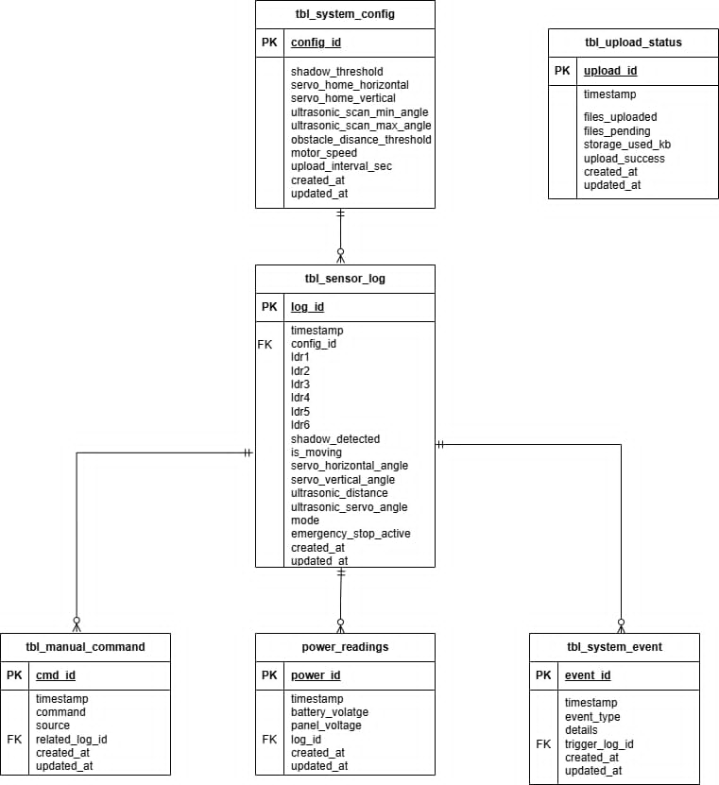
Figure 2.0 Entity-Relationship Diagram

4. Detailed Design

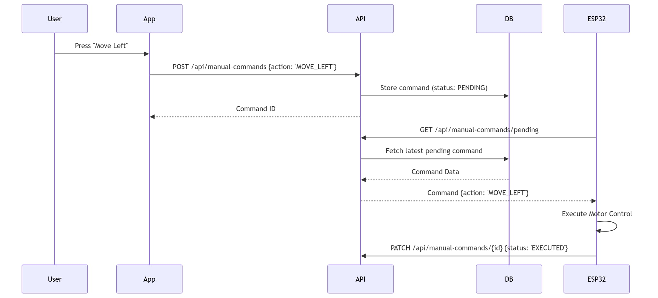
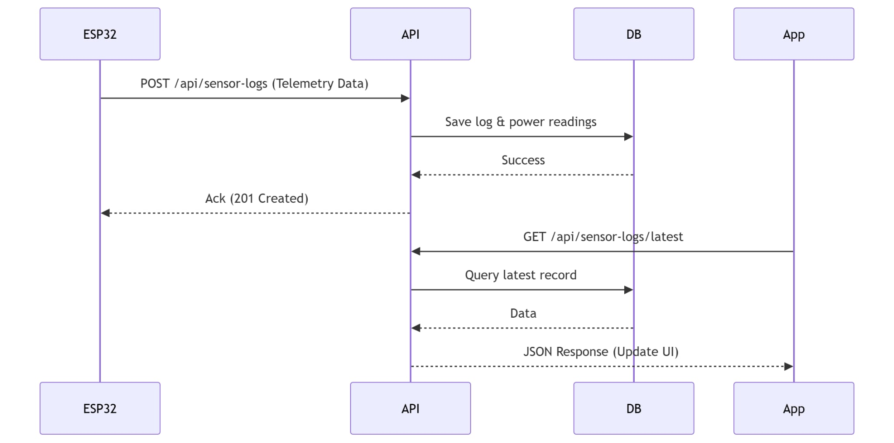
4.1. Telemetry Polling Sequence
Figure 3.0 Telemetry Polling Sequence Diagram

Figure 4.0 Manual Command Sequence Diagram

4.2. Manual Command Sequence

5. Human Interface Design

6.1. Module Interface

6.1.1 Solar Station Dashboard
The Solar Station Dashboard is the central monitoring hub of the application, designed with a modern, high-contrast dark interface (Glassmorphism style) to facilitate rapid data interpretation. It prioritizes real-time telemetry through a structured information hierarchy.

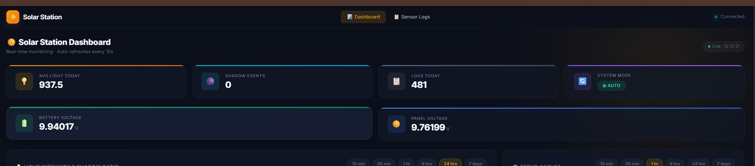

Figure 5.0 Solar Station Dashboard

6.1.2 Analytical Charts & Trends
The dashboard incorporates high-fidelity, interactive analytical charts designed to visualize historical telemetry and system behavior. These visualizations provide critical insights into environmental conditions and hardware performance over time.

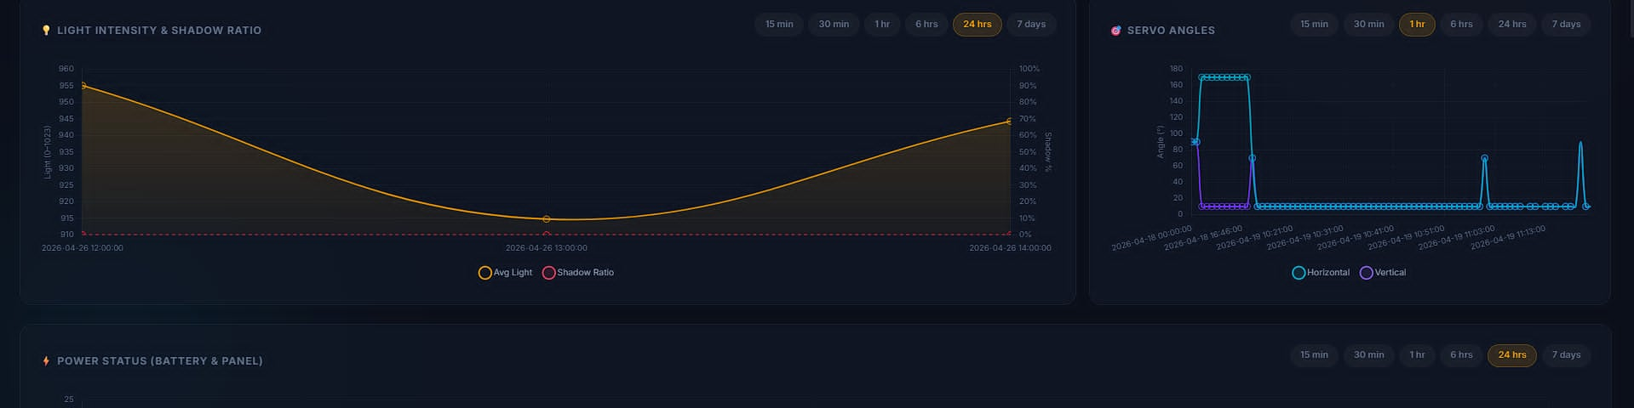

Figure 6.0 Analytical Charts & Trends

6.1.3 System Status & Event Monitoring
This section provides a granular, real-time breakdown of the station's operational health and data synchronization status. It is designed for technical auditing and immediate troubleshooting of the hardware-to-cloud pipeline.
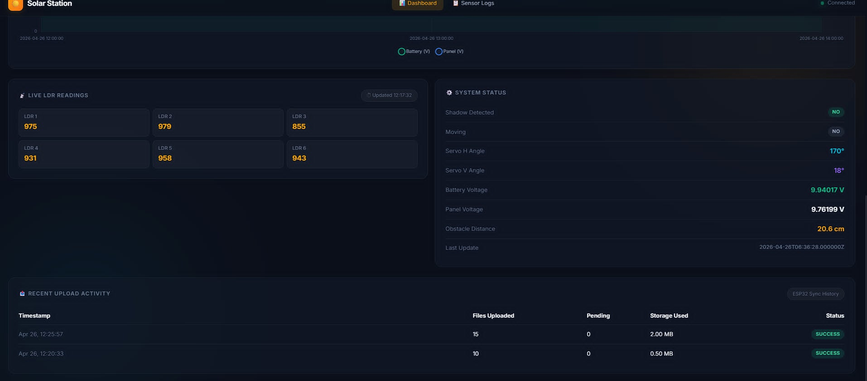

Figure 7.0 System Status & Event Monitoring

6.1.4 Sensor Log Interface
The Sensor Log interface provides a comprehensive historical record of all raw telemetry data captured by the station. It features a tabular view detailing precise timestamps, light intensity values from the six-sensor LDR array, servo angles, power metrics (battery and panel voltages), and ultrasonic distance readings. The module includes advanced filtering capabilities by date range, shadow detection status, and operational mode, allowing for granular data analysis and performance auditing.

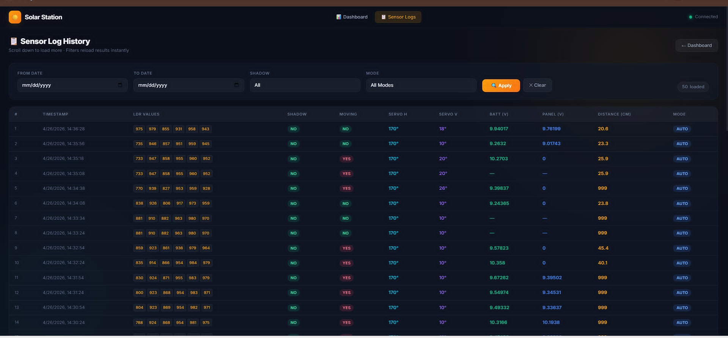

Figure 8.0 Sensor Log Interface
6.1.5 Live Dashboard Interface
The Live Dashboard serves as the central monitoring screen of the system. It displays real-time sensor data from the solar tracker device including light intensity, battery voltage, panel voltage, pan angle, tilt angle, and ultrasonic distance. A status banner at the top notifies the user when the API is unreachable and shows the last known data. The STATUS card indicates the current operation mode (Manual or Automatic) and shadow detection state. Each sensor metric is displayed in its own card with a corresponding icon and color-coded value for quick readability. A progress bar visually represents the light intensity average from six LDR sensors. The bottom navigation bar allows the user to switch between Control, Dashboard, Events, and Settings modules.

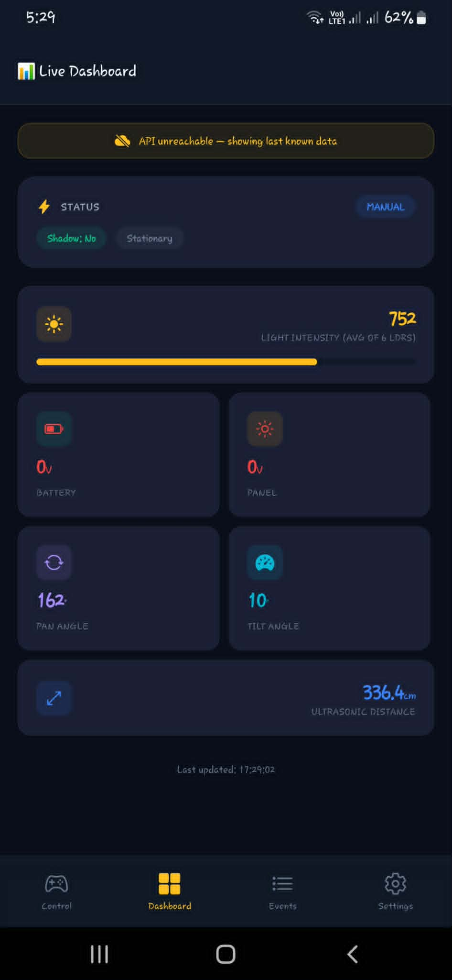.

Figure 9.0 Live Dashboard Interface

6.1.6. Control Interface
The Control Interface, titled Solar Controller, allows the user to manually operate the solar tracking station through Bluetooth connectivity, with a status banner at the top indicating the connection state and an option to disconnect. A Manual Mode toggle switch enables the user to switch between automatic tracking and manual control. The interface is divided into two sections: Station Movement, which features a cross-shaped directional pad with FWD, BWD, LEFT, and RIGHT buttons and a red STOP button at the center to halt all motion; and Panel Servos, which provides TILT UP, TILT DN, PAN L, and PAN R buttons to manually adjust the solar panel's vertical and horizontal orientation using servo motors.
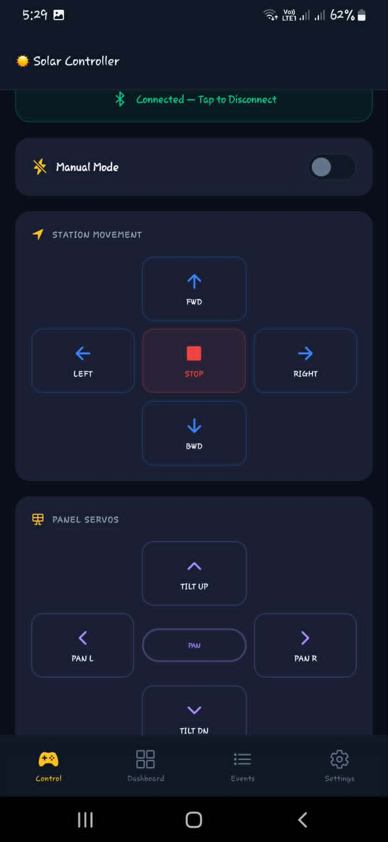
Figure 10.0 Control Interface

6.1.7. Events & Logs Interface
The Events & Logs Interface displays a chronological list of system-generated activity records that auto-refresh based on a set polling interval, with a banner notification shown when the API is unreachable and cached events are being displayed instead. Each event entry consists of a color-coded icon, an event title, a brief description, and a timestamp indicating how long ago the event occurred, covering system activities such as System Start (system initialized successfully), Mode Change (switched to AUTO mode), Shadow Detected (shadow detected on panel surface), Movement Start (station moving to find better sunlight), and Obstacle Detected (obstacle detected at 35cm — stopped), allowing users to monitor and review the operational history of the solar tracking system at a glance.
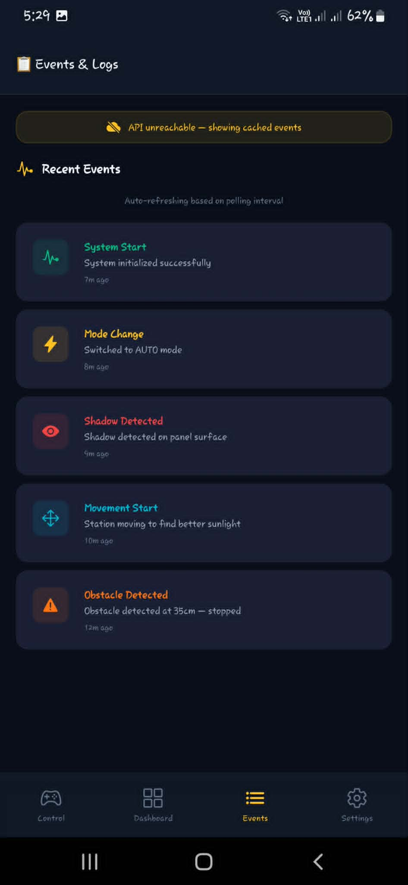
Figure 11.0 Events & Logs Interface

6.1.4. Settings Interface
The Settings Interface provides configuration options organized into three sections: Data Polling, which allows the user to set the data refresh interval at 1s, 2s, 5s, or 10s; Server Configuration, which allows the user to input the API Base URL for connecting the mobile application to the backend server; and System Calibration, which provides adjustable parameters for fine-tuning the solar tracker hardware, including the Shadow Threshold (LDR value for shadow detection), Servo Home (H) and Servo Home (V) (default horizontal and vertical servo positions in degrees), Motor Speed (PWM value controlling station movement speed), and Obstacle Limit (minimum distance in centimeters before the station stops to avoid collision).
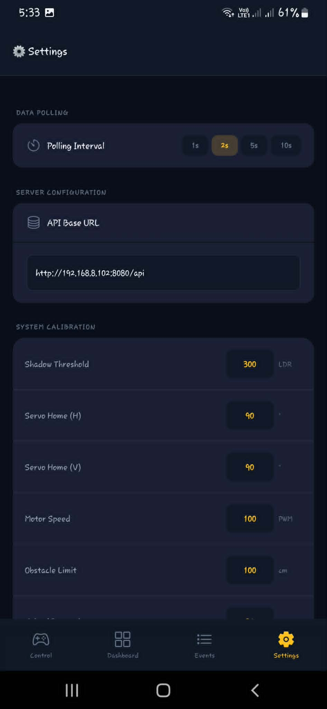
Figure 12.0 Settings Interface

